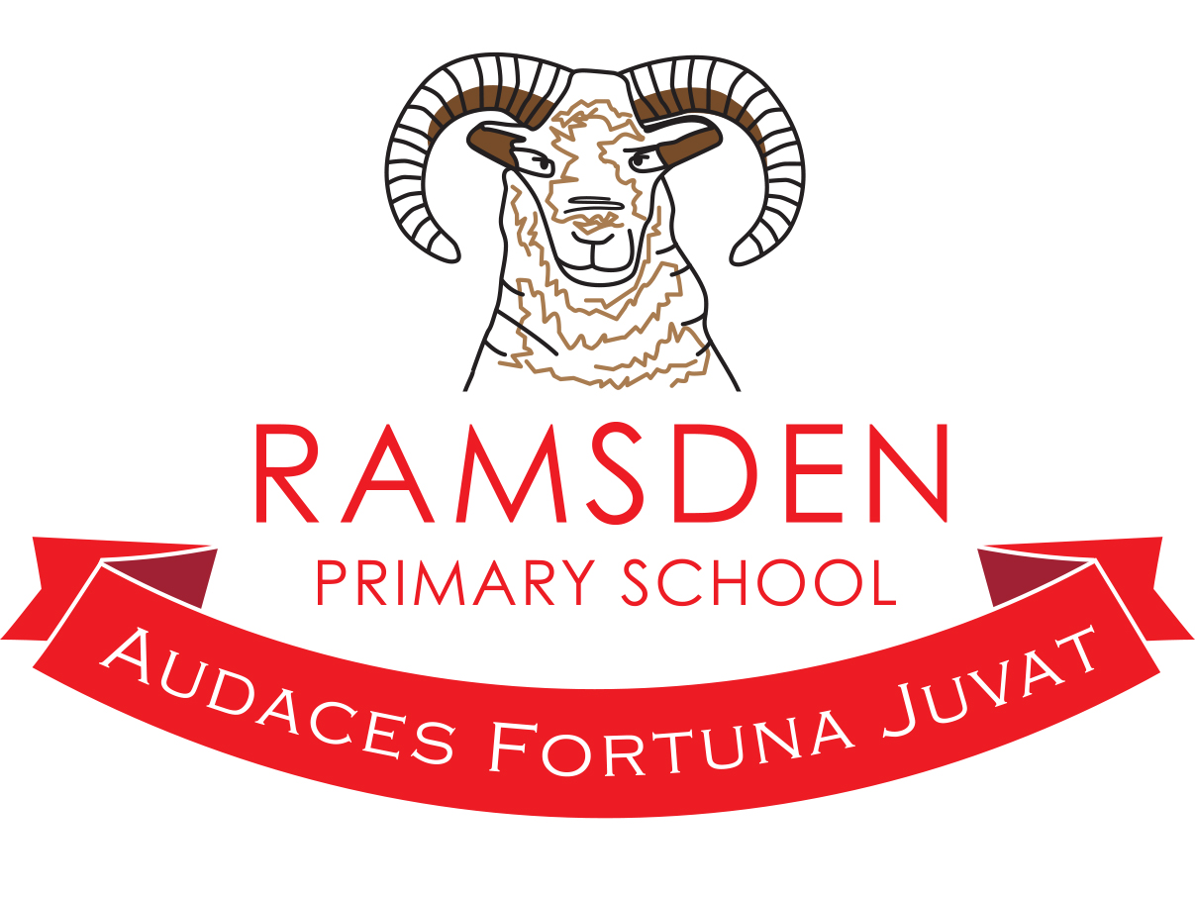Year Long Term Plan
2019 – 2020

 | Autumn 1 | Autumn 2 | Spring 1 | Spring 2 | Summer 1 | Summer 2
The Ramsden Ruminator
Class Text | Cave Boy, Stig of the Dump The Iron Man |  | Escape from Pompeii, The Secret of black Rock
Maths | Place value  By the end of this topic, pupils will:  - Count from 0 in multiples of 4, 8, 50 and 100; find 10 or 100 more or less than a number  - Recognise the value of digits in a 3-digit number  - represent numbers in different ways  - Read and write numbers to 1000  - Solve problems  Statistics  - Interpret and present data using bar charts, pictograms and tables  - Solve one step and two step questions using information in scaled bar charts, pictograms and tables. | Addition and Subtraction  - Add and subtract mentally with up to 3-digits  - Perform columnar methods of addition and subtraction  - Estimate answers and using the inverse to check calculations  - Solve problems  Money  - know the value of each coin and note and understand what these values represent  - understand that money can be represented in different ways but still have the same value  amount.  - Add coin values together and calculate change  - Convert pence to pounds | Number- Multiplication and Division  Recall and use multiplication and division facts for the 3, 4 and 8 multiplication tables  Write and calculate mathematical statements for multiplication and division using the multiplication tables that they know, including for two-digit numbers times one-digit numbers, using mental and progressing to formal written methods  Solve problems, including missing number problems, involving multiplication and division, including positive integer scaling problems and correspondence problems in which n objects are connected to m objects.  Identify, make and add equal groups.  Multiply and divide by 3.  Lesson 3 - To be able to divide by 3.  Use the 3 times table to multiply and divide.  Multiply and divide by 4.  Use the 4 times table to multiply and divide.  Multiply and divide by 8.  Use the 8 times table to multiply and divide.  Measurement: length and perimeter  Measure, compare, add and subtract: lengths (m/cm/mm); mass (kg/g); volume/capacity (l/ml)  Measure the perimeter of simple 2-D shapes  Add and subtract amounts of money to give change, using both £ and p in practical contexts  Tell and write the time from an analogue clock, including using Roman numerals from I to XII, and 12-hour and 24-hour clocks  Estimate and read time with increasing accuracy to the nearest minute; record and compare time in terms of seconds, minutes and hours; use vocabulary such as o'clock, am/pm, morning, afternoon, noon and midnight  Know the number of seconds in a minute and the number of days in each month, year and leap year  Compare durations of events.  Fractions  Unit and non-unit fractions.  Making the whole.  Tenths.  Count in tenths.  Tenths as decimals.  Fractions on a number-line.  Fractions as a set of objects (1).  Fractions as a set of objects (2).  Fractions as a set of objects (3).
Writing Foci | Non chronological reports, stories by the same author, Haiku poems  SPAG  - Ready to write: Full stops, capital letters, exclamation marks, question marks, commas, apostrophes.  - Subordination and coordination.  - Past and present tense.  - Determiners. | Recipes  Instructions  Just so stories  Nonsense poems  SPAG  - Subordination and coordination.  - Past and present tense.  - Determiners.  - Conjunctions | To spell most words with the prefixes dis-, mis-,bi-, re- and de- correctly (e.g. disobey, mistreat, bicycle, reapply, defuse).  To spell most words with the suffix -ly with no change to the root word; root words that end  in ‘le’,‘al’ or ‘ic’ and the exceptions to the rules.  To spell words with added suffixes beginning with a vowel (-er/-ed/- ing) to words with  more than one syllable (unstressed last syllable,e.g. limiting offering).  To spell words with added suffixes beginning with a vowel (-er/-ed/- en/-ing) to words with more than one syllable (stressed last syllable, e.g. forgotten beginning).  To spell some more complex homophones and near-homophones, including here/hear, brake/break and mail/ male.  To use the first two or three letters of a word to check its spelling in a dictionary.  To begin to use ideas from their own reading and modelled examples to plan their writing.  To proofread their own and others’ work to check for errors (with increasing accuracy) and to make improvements.  To begin to organise their writing into paragraphs around a theme.  To compose and rehearse sentences orally (including dialogue).  To demonstrate an increasing understanding of purpose and audience by discussing writing similar to that which they are planning to write in order to understand and learn from its structure, vocabulary and grammar.  To begin to use the structure of a wider range of text types (including the use of simple layout devices in non-fiction).  To make deliberate ambitious word choices to add detail.  To begin to create settings, characters and plot in narratives.  To use ‘a’ or ‘an’ correctly throughout a piece of writing.  To adverbs and prepositions to show time, place and cause.  To use the full range of punctuation from previous year groups.  To punctuate direct speech accurately, including the use of inverted commas. |  | To spell word with the / eɪ/ sound spelt ‘ei’, ‘eigh’, or ‘ey’ (e.g. vein, weigh, eight, neighbour, they, obey).  To spell words with the /ɪ/ sound spelt ‘y’ in a position other than at the end of words (e.g. mystery, gym).  To spell words with a /k/ sound spelt with ‘ch’ (e.g. scheme, chorus, chemist, echo, character).  To spell words ending in the /g/ sound spelt ‘gue’ and the /k/ sound spelt ‘que’ (e.g. league, tongue, antique, unique).  To spell words with a short /u/ sound spelt with ‘ou’ (e.g. young, touch, double, trouble, country).  To spell words ending with the /zher/ sound spelt with ‘sure’ (e.g. measure, treasure, pleasure, enclosure).  To spell words ending with the /cher/ sound spelt with ‘ture’ (e.g. creature, furniture, picture, nature, adventure).  To recognise and use the terms preposition, conjunction, word family, prefix, clause, subordinate clause, direct speech, consonant, consonant letter, vowel, vowel letter and inverted commas (or speech marks).  To spell words with a / sh/ sound spelt with ‘ch’ (e.g. chef, chalet, machine, brochure).  To spell all of the Y3 and Y4 statutory spelling words correctly.  To use a neat, joined handwriting style with increasing accuracy and speed.  To continue to use the diagonal and horizontal strokes that are needed to join letters and to understand which letters, when adjacent to one another, are best left un-joined.  To try to maintain the correct tense (including the present perfect tense) throughout a piece of writing with accurate subject/verb agreement.
Science | - By the end of this unit pupils will learn:  - How to identify naturally occurring rocks and what their uses are.  - Group rocks according to their characteristics.  - Plan and carry out an experiment to compare rocks.  - Identify rocks that are used for particular purposes.  - Explore soil and learn how it is formed.  - Describe what a fossil is and how are they formed?  - Identify fossilised remains. | - By the end of this unit pupils will learn:  - Why animals need the right nutrients  - To sort animals according to their diets  - To identify that some animals have skeletons  - To identify and name bones  - About the functions of the skeleton  - How muscles work | By the end of this unit, pupils will have learnt:  To recognise that they need light in order to see things and that dark is the absence of light  To notice that light is reflected from surfaces  To recognise that light from the sun can be dangerous and that there are ways to protect their eyes.  To recognise that shadows are formed when the light from a light source is blocked by a solid object.  To find patterns in the way that the size of shadows change.  To compare how things move on different surfaces  To notice that some forces need contact between 2 objects, but magnetic forces can act at a distance  To observe how magnets attract or repel each other and attract some materials and not others  To compare and group together a variety of everyday materials on the basis of whether they are attracted to a magnet, and identify some magnetic materials  To describe magnets as having 2 poles  To predict whether 2 magnets will attract or repel each other, depending on which poles are facing.
Art and Design | Art and Design  - By the end of this unit pupils will learn:  • How to create sketch books to record their observations and use them to review and edit ideas.  • How to improve their mastery of art and design techniques, including: drawing, painting and sculpture with a range of materials (for example, pencil, charcoal, paint and clay).  • Know about great artists, architects and designers in history. | - | By the end of this unit, pupils will have learnt:  To experiment with different grades of pencil.  To draw for a sustained period of time at their own level.  To mix a variety of colours and know which primary colours make secondary colours.  To explore patterns and shape.  To compare their own work to that of others and to evaluate.
Computing | By the end of this topic pupils will :  - Create a chart that represents a sequential algorithm.  - Know how to write a program to stimulate a physical system.  - Use “if “command to introduce selection.  - Incorporate a timer into a program.  - Know what a variable is and how to use one.  - Create a program that repeats actions indefinitely.  - Debug a simple program |  | By the end of this unit, pupils will have learnt:  To use technology safely, respectfully and responsibly.  To identify ways to report concerns about content and contact.  To use search technologies effectively, appreciate how results are selected.  To elect, use and combine a variety of software (including internet services) on a range of digital devices.
DT | - | By the end of this unit pupils will learn:  - To investigate how familiar objects use air to move them  - To look at techniques for making simple pneumatics systems  - How to gather ideas to make own moving monster  - To make own moving monster with a pneumatic system | By the end of this unit, pupils will have learnt:  To select material suitable for the task.  To describe the purpose of their product.  To use annotated sketches.  To assemble, join and combine materials.  To identify strengths and areas for development in their products.  Use techniques that involve a number of steps to make their volcanoes.
Languages | By the end of this topic pupils will :  - Be able to greet people and introduce themselves in German |  | By the end of this topic pupils will :  - Be able to count to twenty in German.  - Be able to list the colours in German.
History | - By the end of this topic pupils will:  - Understand when the Stone, Iron and Bronze Age were.  - Learn how people Survived in the Stone Age  - Know about Skara Brae and its importance in learning about the past  - Be able to recall similarities and differences between Bronze Age children’s lives and their own.  - Explain how Stonehenge gives us information about the past.  - Discuss importance of hillfronts during the Iron Age. |  | Geography  By the end of this unit, pupils will have learnt:  To use 4 compass points to follow/give directions.  Begin to as/initiate geographical questions.  Use atlases as a source of information.  Analyse evidence and begin to draw conclusions.  Locate places on larger scale maps.  Make a simple scale drawing.  Understand why a key is needed.
 |  |  | - By the end of this topic pupils will:  Appreciate and understand a wide range of music drawn from different traditions and from great composers. |  | - By the end of this topic pupils will:  Improvise and compose music using the interrelated dimensions of music and musical notation.
- By the end of this topic pupils will:
- Be able to swim 25M confidently, competently and proficiently.
- Use a range of different swimming strokes.
- Understand the importance of water safety.
- Play competitive games. Apply the basic principles of attack and defence.

RE | - By the end of this topic pupils will:  - Know where Christianity was founded and by whom?  - Understand the main beliefs of Christians?  - Can explain how God creating the World according to Christians?  - Know why Christians celebrate Christmas and Easter?  - Understand the importance of the Bible and the Lord’s Prayer to Christians?  - Know where Judaism was founded and by whom?  - Know where Hinduism was founded and by whom? |  | By the end of this unit, pupils will have learnt:  To explore the day-to-day lives and practices of various religions.  To understand how books, symbols and art convey beliefs.  To make sense of right and wrong and the choices we make.  To understand the key teachings of various religions.
PSHCE | - Children to complete the Sterling Wellbeing questionnaire. |  | - Skills builder – aiming high and leadership.

